**Google Analytics Assignment 1**

google analytics  
aSSIGNMNET 1

**Submitted by:**

Karan AShok

1. What is the overall E-commerce Conversion Rate?

2.42%

1. What is the overall AOV?

$302.76

1. Please list the Top 5 products by Revenue.
   1. Nest® Cam Indoor Security Camera - USA
   2. Nest® Learning Thermostat 3rd Gen-USA - Stainless Steel
   3. Google 5-Panel Cap
   4. Nest® Cam Outdoor Security Camera - USA
   5. Google Hard Cover Journal
2. Please list the Top 5 Site Sources and Mediums.

**Top 5 Sources:**

1. google
2. (direct)
3. youtube.com
4. mail.googleplex.com
5. analytics.google.com

**Top 5 mediums:**

1. organic
2. referral
3. (none)
4. affiliate
5. cpc
6. Is there an outlier transaction and, if so, what is the more accurate figure for AOV (hint: click on order coupon code)?

Yes, as depicted in the screenshot below, there are 5 transactions which can be considered as outliers.

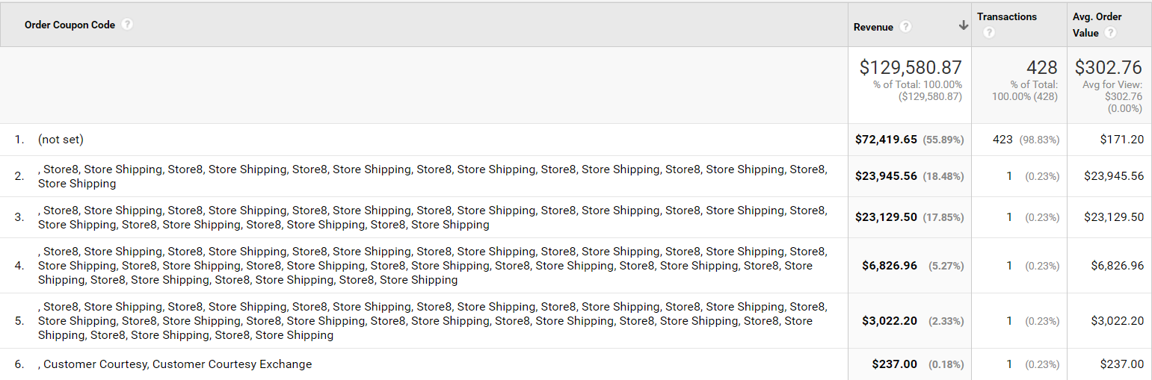

On deleting these outliers, we get a more accurate AOV : $171.20

1. What was the most effective campaign type taking into account conversion rate and revenue?

Campaign: AW- Accessories

Conversion Rate: 2.3%

Revenue: $2072.33

1. Compare new and returning visitors for sessions with:
   * product views
   * add-to-cart
   * check-out
   * transactions

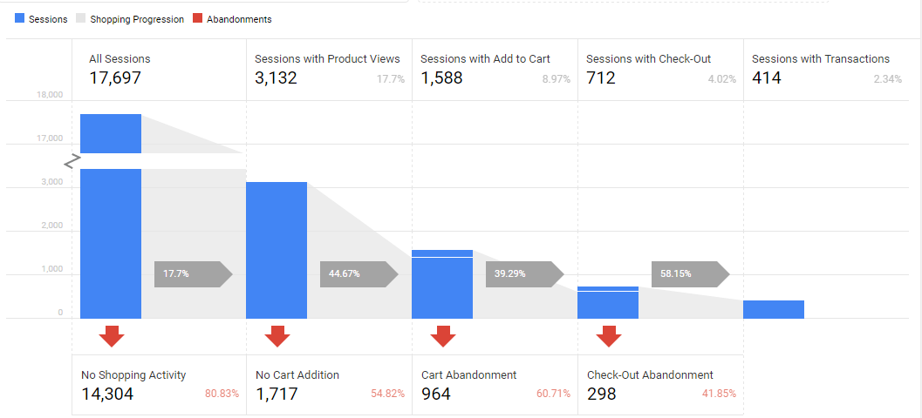

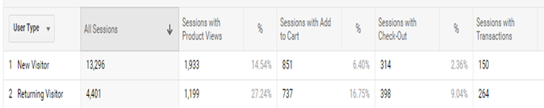

1. What is the most critical point in the lower funnel for both new and returning customers?

According to us, the Payments point is the most critical point in the lower funnel for both new and returning customers. If once the Payments process is crossed over, then most people complete the review process (93%) and hence the purchase.

1. Is there a relationship between product list position and click through and revenue? Provide chi-square and/or correlations.

The following data was used to run a regression

**Dependent Variables**: Product Revenue

**Independent Variables**: Product List Clicks, Product List Position

|  |  |  |
| --- | --- | --- |
| Product List Position | Product List Clicks | Product Revenue |
| 1 | 327 | $ 3,875.02 |
| 2 | 193 | $ 2,054.88 |
| 3 | 218 | $ 8,597.68 |
| 4 | 235 | $ 6,872.99 |
| 5 | 203 | $ 250.02 |
| 6 | 197 | $ 291.62 |
| 7 | 91 | $ 407.22 |
| 8 | 69 | $ 74.23 |
| 9 | 63 | $ 14.05 |
| 10 | 62 | $ 462.87 |
| 11 | 59 | $ 247.13 |
| 12 | 67 | $ 492.68 |
| 13 | 0 | $ 0 |
| 14 | 0 | $ 0 |
| 15 | 0 | $ 0 |

Based on regression, the following results were obtained.

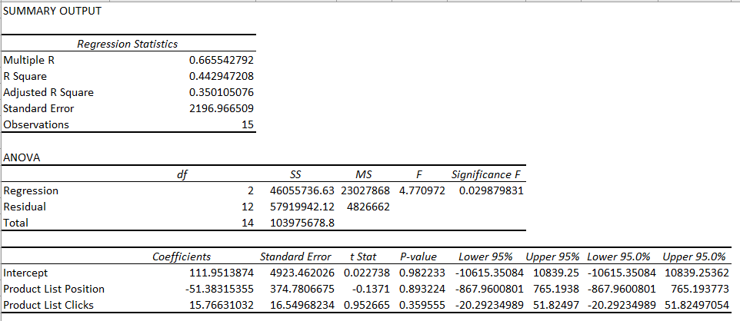

The linear equation derived from the regression is

***Product Revenue = 111.95 + 15.766 (Product List Clicks) – 51.3832 (Product List Position)***

Interpretations:

* As the number of Product List Clicks increases, the Product Revenue increases ***15.766*** times.
* As the Product List Position increases i.e it moves further down, the Product Revenue decreases ***51.3832*** times.

The correlation matrix is as follows:

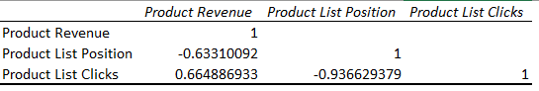

Interpretations:

* Product List Position is negatively correlated with Product Revenue.
* Product List Clicks is positively correlated with Product Revenue.

1. What are the 5 product categories that generate the most revenue?

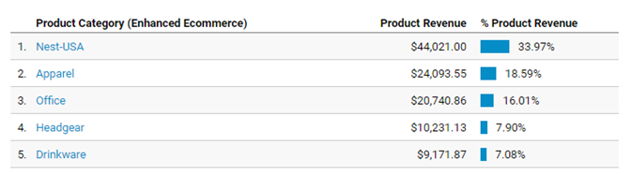

1. Point out the three products with the biggest disconnect between CTR and subsequent specific cart or check-out abandonment issues.

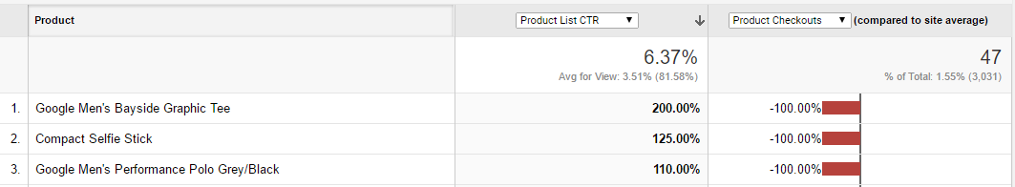

The three products with the biggest disconnect between CTR and subsequent specific cart or check-out abandonment issues are:

1. Google Men’s Bayside Graphic Tea

2. Compact Selfie Stick

3. Google Men’s Performance Polo Grey/Black

**12**. What is cart to detail rate and buy to detail rate? How is it different?

Cart-to-Detail Rate refers to the number of products added per number of product-detail views

Buy-to-Detail Rate refers to the number of products purchased per number of product-detail views